Week 5: Power BI Retail Report
By: Eunice Etefia
I built a 3-page Power BI report using the retail dataset.
- Page 1 is the Executive Overview
- Page 2 is Product Analysis
- Page 3 is Customer & Location.
Page 1: Executive Overview
This page shows the main numbers for the business:
- Total Revenue: ₦2,658,138,354.84
- Total Profit: ₦735,375,165.52 (about 27.7% of revenue)
- Total Orders: 50,000
- Total Quantity: 119,549
- Average Order Value: ₦53,162.77

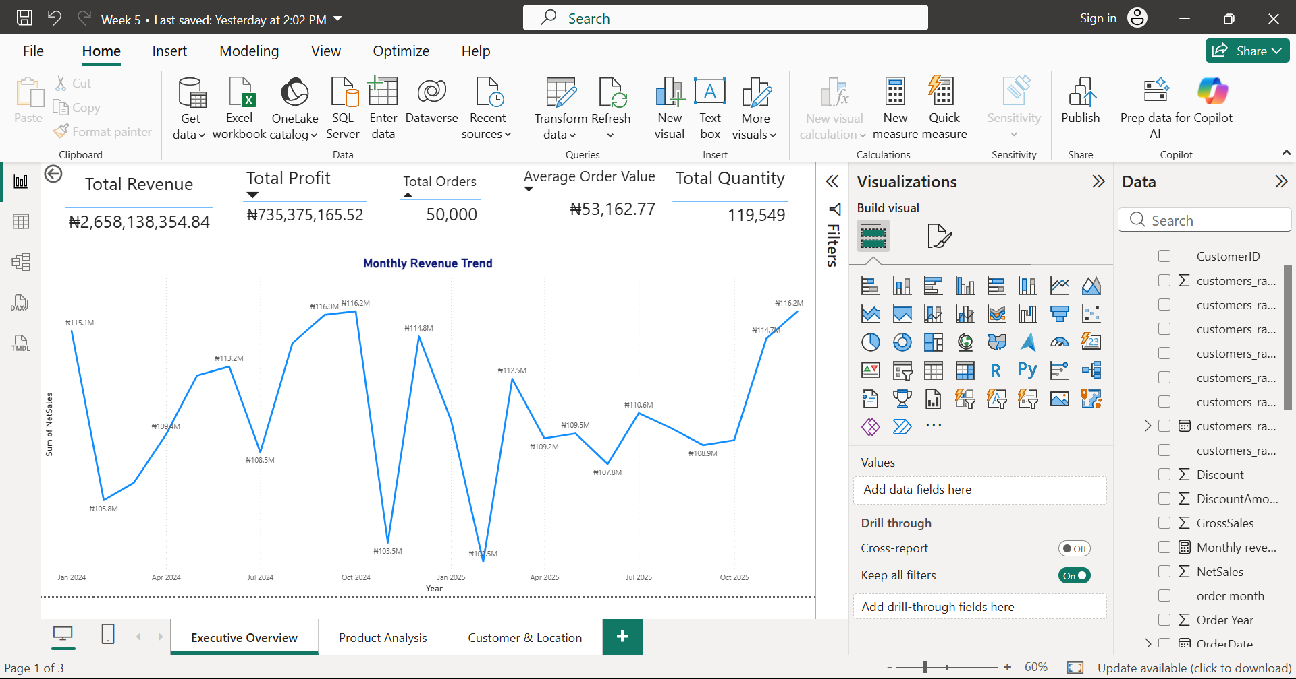
I also made a line chart of Monthly Revenue for 2024 and 2025. Revenue stays between about ₦102M and ₦116M each month. With the highest generating month as October 2024 (about ₦116.2M) and the lowest is February 2025 (about ₦102.5M).
There was big steady growth, just ups and downs.

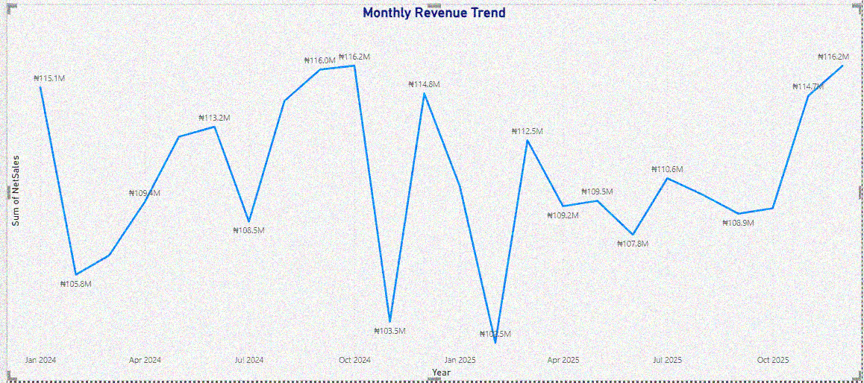

Call to action: Find out what happened in the strong months (September to October 2024) and the weak months (November 2024, February 2025) so the good results can be repeated and the dips avoided.
Page 2: Product Analysis
- Sales by category: Furniture is highest at ₦0.51bn, then Groceries (₦0.48bn), Electronics (₦0.46bn), Beauty (₦0.43bn), Clothing (₦0.40bn), and Sports is lowest (₦0.38bn).
- Profit by category: same order. Furniture makes the most profit (₦142M) and Sports the least (₦106M).
- Top products: Beverages Plus 239 is the top product with about ₦37.2M in sales. Next are Skincare Plus 34 (about ₦28.5M) and Chairs Basic 80 (about ₦28.3M), then Skincare Pro 250 (about ₦27.7M) and Makeup Pro 238 (about ₦27.3M).
- Product performance: a table showing each product's quantity, sales and profit.

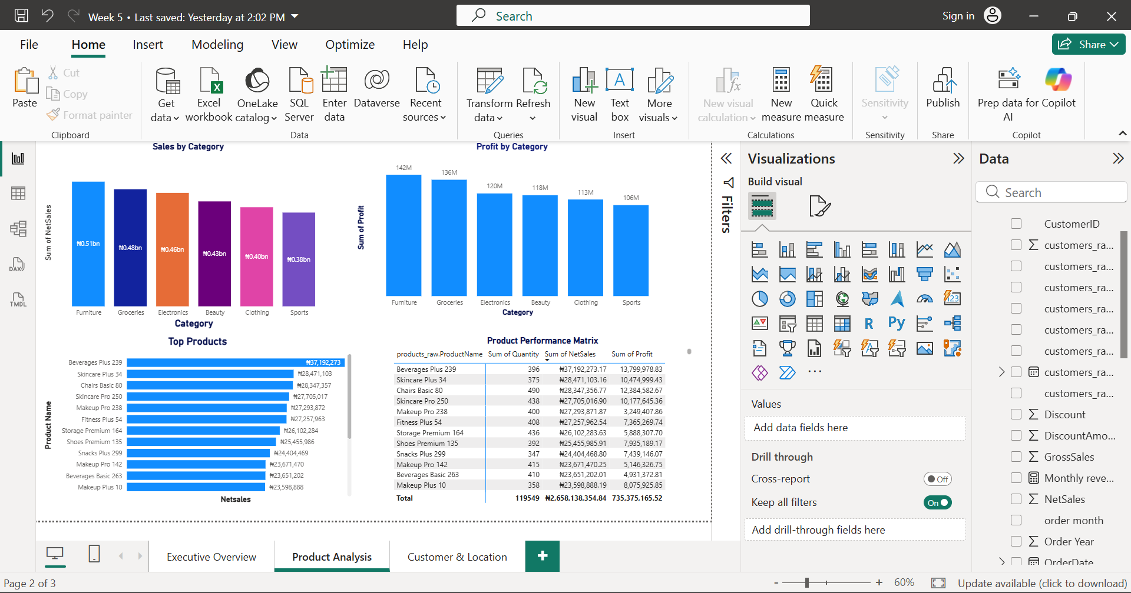
Call to action: Keep Furniture well stocked and promoted, since it leads in both sales and profit. Look at why Sports is lowest and whether it needs better promotion or pricing.

Page 3: Customer & Location
- Customer segments: Standard brings the most revenue (₦1.65bn, 62.18%), then Premium (₦0.72bn, 27.25%) and Corporate (₦0.26bn, 9.81%)
- Sales by store: the top stores are close together, S025 (₦111.2M), S017 (₦110.7M) and S012 (₦109.8M).
- Top customers: the biggest customer is Ngozi Balogun (₦15.86M in sales, ₦4.14M profit). The next four (Fatima Thomas, Daniel Olawale, David Johnson, Tunde Usman) are all around ₦15M.
- Sales by region: shown on a map. (Add a sentence only after you check what the map is actually showing.)

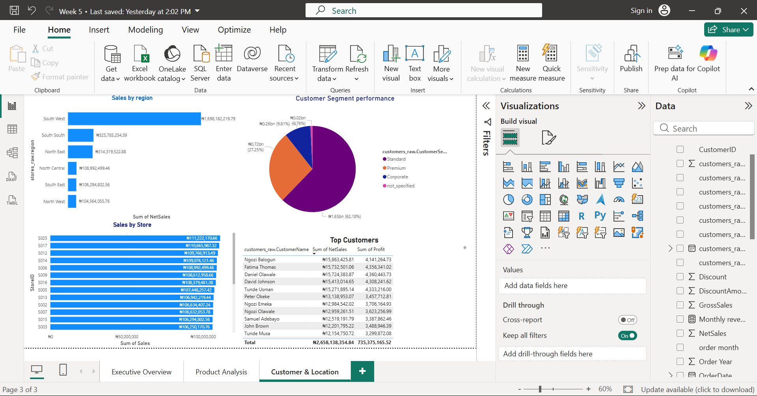

Call to action: Keep the Standard customers happy since they bring most of the money, and try to grow corporate customers since they are the smallest group. Reward the top customers.
Overall call to action
The business makes about 27.7% profit and revenue is steady each month. To grow, focus on the strongest categories and customers, look into the weak months and the weakest category, and improve the data quality (missing dates and unspecified segments).

